.

<(NAME) Project: (Workstream NAME)>

<Title: 3 Layer (Base, Design and Product) Specification Template>

<Version>.<Revision>.<Errata>

Author: <Primary>

Author: <Secondary, etc. Delete if unnecessary>

# Version History

Note, refer to the OCP Contribution Versions, Revisions and Errata best practices documentation. Generally speaking, Versions and revisions are made to this document and logged here. Errata is a separate document such that the contribution specification document it refers to was not revised. Ex: Version 1, Errata E1

| **Date** | **Version #** | **Author** | **Description** |
| --- | --- | --- | --- |
| 01 JAN 24 | 1.0.0 | Bijan Nowroozi/Michael Shill/Rob Coyle | Initial Release |
| 17 JUN 24 | 1.0.1 | Bijan Nowroozi | Modified title page to include project information and added some context on p.10 openness tenet, Appendix C updates |
| 30 SEP 24 | 1.1.0 | Bijan Nowroozi | Added usage note and compliance sections |
|  |  |  |  |
|  |  |  |  |
|  |  |  |  |
|  |  |  |  |

# 

# Current Template Version:

3 Layer (Base, Design and Product) Specification Template V1.1.0

**Table of Contents**

**Version History 2**

**Current Template Version: 2**

**1. License 6**

1.1. OPTION A: OCP CLA OR 6

1.2. OPTION B: Open Web Foundation (OWF) CLA 7

**2. Acknowledgements 8**

**3. Compliance with OCP Tenets 9**

3.1. Openness 9

3.2. Efficiency 9

3.3. Impact 10

3.4. Scale 10

3.5. Sustainability 10

**4. Scope 12**

4.1. Base Specification Layer 12

4.2. Design Specification Layer 13

4.3. Product Specification Layer 14

**5. Overview 16**

**6. Base Specifications 16**

**6.1. Repository Location (Strongly Recommended) 16**

**6.2. Environmental Regulatory Compliance and Requirements 16**

**6.3. Physical Specifications 17**

**6.4. Mechanical 18**

6.4.1. Rack Compatibility 18

6.4.2. General Requirements 18

**6.5. Electrical Requirements 19**

**6.6. Thermal Design Requirements 19**

**6.7. Interfaces 20**

6.7.1. Signal List 20

6.7.2. Rear Side Power, I/O, Expansion Board and Midplane Subsystems 21

**6.8. Onboard Power System 21**

**6.9. Prescribed Materials 22**

**6.10. System Firmware 22**

**6.11. Hardware Management 22**

**6.12. Compliance 23**

**6.13. Security 23**

**6.14. Software Support (Strongly recommended) 24**

**6.15. Arm SystemReady (only for Arm-based Systems) Requirement 24**

**6.16. References (recommended) 25**

**7. Design Specifications 25**

7.1. Repository Information 25

**7.2. Environmental Regulatory Compliance and Requirements 26**

**7.3. Physical Specifications 27**

**7.4. Mechanical 27**

7.4.1. Rack Compatibility 28

7.4.2. General Requirements 28

**7.5. Electrical Requirements 28**

**7.6. Thermal Design Requirements 29**

**7.7. Interfaces 29**

7.7.1. Signal List 30

7.7.2. Rear Side Power, I/O, Expansion Board and Midplane Subsystems 30

**7.8. Onboard Power System 31**

**7.9. Prescribed Materials 31**

**7.10. System Firmware 31**

**7.11. Hardware Management 32**

**7.12. Compliance 32**

**7.13. Security 33**

**7.14. Software Support (Strongly recommended) 34**

**7.15. Arm SystemReady (only for Arm-based Systems) Requirement 34**

**7.16. References (recommended) 34**

**8. Product Specifications 35**

8.1. Repository Information 35

**Please identify OCP GitHub repository information for the Product Specifications. 36**

**8.2. Environmental Regulatory Compliance and Requirements 36**

**8.3. Physical Specifications 37**

**8.4. Mechanical 37**

8.4.1. Rack Compatibility 38

8.4.2. General Requirements 38

**8.5. Electrical Requirements 38**

**8.6. Thermal Design Requirements 39**

**8.7. Interfaces 39**

8.7.1. Signal List 40

8.7.2. Rear Side Power, I/O, Expansion Board and Midplane Subsystems 40

**8.8. Onboard Power System 41**

**8.9. Prescribed Materials 41**

**8.10. System Firmware 41**

**8.11. Hardware Management 42**

**8.12. Compliance 42**

**8.13. Security 43**

**8.14. Software Support (Strongly recommended) 44**

**8.15. Arm SystemReady (only for Arm-based Systems) Requirement 44**

**8.16. References (recommended) 44**

**Appendix A - Checklist for Steering Committee (SC) approval of this Specification (to be completed by contributor(s) of this Spec) 45**

**Appendix B-__ <supplier name> - OCP Supplier Information and Hardware Product Recognition Checklist 46**

**Appendix C - Contribution Process FAQs 48**

# 

# License

PLEASE PICK EITHER THE OCP CLA OPTION OR THE OWF OPTION. ONLY ONE CAN BE USED. DELETE THE ONE NOT USED.

* OPTION A: OCP CLA
* OPTION B: Open Web Foundation (OWF) CLA

## **OPTION A: OCP CLA**

Contributions to this Specification are made under the terms and conditions set forth in Open Compute Project Contribution License Agreement (“OCP CLA”) (“Contribution License”) by:

**[Contributor Name(s) or Company name(s)]**

You can review the Contributor License(s) for this Specification on the OCP website at <https://www.opencompute.org/legal-documents>. For actual executed copies of either agreement, please contact OCP directly.

Usage of this Specification is governed by the terms and conditions set forth in:

[Select One ONLY]

* Modified OWFa1.0 Final Specification Agreement (FSA) (As of August 16, 2021) or
* Open Compute Project Hardware License – Permissive (“OCPHL Permissive”) or
* Open Compute Project Hardware License – Reciprocal (“OCPHL Reciprocal”)

also known as a “Specification License”.

**Notes**:

The above license does not apply to the Appendix or Appendices. The information in the Appendix or Appendices is for reference only and non-normative in nature.

NOTWITHSTANDING THE FOREGOING LICENSES, THIS SPECIFICATION IS PROVIDED BY OCP "AS IS" AND OCP EXPRESSLY DISCLAIMS ANY WARRANTIES (EXPRESS, IMPLIED, OR OTHERWISE), INCLUDING IMPLIED WARRANTIES OF MERCHANTABILITY, NON-INFRINGEMENT, FITNESS FOR A PARTICULAR PURPOSE, OR TITLE, RELATED TO THE SPECIFICATION. NOTICE IS HEREBY GIVEN, THAT OTHER RIGHTS NOT GRANTED AS SET FORTH ABOVE, INCLUDING WITHOUT LIMITATION, RIGHTS OF THIRD PARTIES WHO DID NOT EXECUTE THE ABOVE LICENSES, MAY BE IMPLICATED BY THE IMPLEMENTATION OF OR COMPLIANCE WITH THIS SPECIFICATION. OCP IS NOT RESPONSIBLE FOR IDENTIFYING RIGHTS FOR WHICH A LICENSE MAY BE REQUIRED IN ORDER TO IMPLEMENT THIS SPECIFICATION. THE ENTIRE RISK AS TO IMPLEMENTING OR OTHERWISE USING THE SPECIFICATION IS ASSUMED BY YOU. IN NO EVENT WILL OCP BE LIABLE TO YOU FOR ANY MONETARY DAMAGES WITH RESPECT TO ANY CLAIMS RELATED TO, OR ARISING OUT OF YOUR USE OF THIS SPECIFICATION, INCLUDING BUT NOT LIMITED TO ANY LIABILITY FOR LOST PROFITS OR ANY CONSEQUENTIAL, INCIDENTAL, INDIRECT, SPECIAL OR PUNITIVE DAMAGES OF ANY CHARACTER FROM ANY CAUSES OF ACTION OF ANY KIND WITH RESPECT TO THIS SPECIFICATION, WHETHER BASED ON BREACH OF CONTRACT, TORT (INCLUDING NEGLIGENCE), OR OTHERWISE, AND EVEN IF OCP HAS BEEN ADVISED OF THE POSSIBILITY OF SUCH DAMAGE.

## OPTION B: Open Web Foundation (OWF) CLA

Contributions to this Specification are made under the terms and conditions set forth in Modified OWF-CLA-1.0 (As of August 16, 20213) (“Contribution License”) by:

**[Contributor Name(s) or Company name(s)]**

Usage of this Specification is governed by the terms and conditions set forth in **Modified OWFa1.0 Final Specification Agreement (FSA) (As of August 16, 2021) (“Specification License”).**

You can review the applicable Specification License(s) referenced above by the contributors to this Specification on the OCP website at <http://www.opencompute.org/participate/legal-documents/>. ​​For actual executed copies of either agreement, please contact OCP directly.

**Notes**:

The above license does not apply to the Appendix or Appendices. The information in the Appendix or Appendices is for reference only and non-normative in nature.

NOTWITHSTANDING THE FOREGOING LICENSES, THIS SPECIFICATION IS PROVIDED BY OCP "AS IS" AND OCP EXPRESSLY DISCLAIMS ANY WARRANTIES (EXPRESS, IMPLIED, OR OTHERWISE), INCLUDING IMPLIED WARRANTIES OF MERCHANTABILITY, NON-INFRINGEMENT, FITNESS FOR A PARTICULAR PURPOSE, OR TITLE, RELATED TO THE SPECIFICATION. NOTICE IS HEREBY GIVEN, THAT OTHER RIGHTS NOT GRANTED AS SET FORTH ABOVE, INCLUDING WITHOUT LIMITATION, RIGHTS OF THIRD PARTIES WHO DID NOT EXECUTE THE ABOVE LICENSES, MAY BE IMPLICATED BY THE IMPLEMENTATION OF OR COMPLIANCE WITH THIS SPECIFICATION. OCP IS NOT RESPONSIBLE FOR IDENTIFYING RIGHTS FOR WHICH A LICENSE MAY BE REQUIRED IN ORDER TO IMPLEMENT THIS SPECIFICATION. THE ENTIRE RISK AS TO IMPLEMENTING OR OTHERWISE USING THE SPECIFICATION IS ASSUMED BY YOU. IN NO EVENT WILL OCP BE LIABLE TO YOU FOR ANY MONETARY DAMAGES WITH RESPECT TO ANY CLAIMS RELATED TO, OR ARISING OUT OF YOUR USE OF THIS SPECIFICATION, INCLUDING BUT NOT LIMITED TO ANY LIABILITY FOR LOST PROFITS OR ANY CONSEQUENTIAL, INCIDENTAL, INDIRECT, SPECIAL OR PUNITIVE DAMAGES OF ANY CHARACTER FROM ANY CAUSES OF ACTION OF ANY KIND WITH RESPECT TO THIS SPECIFICATION, WHETHER BASED ON BREACH OF CONTRACT, TORT (INCLUDING NEGLIGENCE), OR OTHERWISE, AND EVEN IF OCP HAS BEEN ADVISED OF THE POSSIBILITY OF SUCH DAMAGE.

# Acknowledgements

The Contributors of this Specification would like to acknowledge the following for their feedback:

List all companies or individuals who may have assisted you with the specification by providing feedback and suggestions but did not provide any IP.

| DELETE THIS BLOCK BEFORE SUBMITTING |
| --- |
| INSTRUCTIONS FOR THE FOLLOWING SECTIONS:   * The following sections, 3-4 are required for contribution. * Replace the section text (keep titles) |

# Compliance with OCP Tenets

Please describe how this Specification complies to the following OCP tenets. Compliance is required for at least four of the five tenets (Sustainability is a required tenet). The ideals behind open sourcing stipulate that everyone benefits when we share and work together. Any open source project is designed to promote sharing of design elements with peers and to help them understand and adopt those contributions. There is no purpose in sharing if all parties aren't aligned with that philosophy. The OCP Incubation Committee will look beyond the contribution for evidence that the contributor is aligned with this philosophy. The contributor actions, past and present, are evidence of alignment and conviction to all the tenets.

A full explanation of the OCP core tenets can be seen [here](https://146a55aca6f00848c565-a7635525d40ac1c70300198708936b4e.ssl.cf1.rackcdn.com/images/bf648bb75091907147e76846cad590f402660d2e.pdf).

## Openness

The measure of openness is the ability of a third party to build, modify, or personalize the device or platform from the contribution. OCP strives to achieve completely open platforms, inclusive of all programmable devices, firmware, software, and all mechanical and electrical design elements, including ancillary, external components or tools such as software utilities necessary to modify or use design contributions. Barriers to achieving this goal should be constantly addressed and actions taken to remove anything that prevents an open platform. Openness can also be demonstrated through collaboration and willingness to share, seek feedback, and accept changes to design and specification contributions under consideration. Ensure this contribution can be extended and enhanced by others.

Project Name:

Workstream (if applicable):

Brief history:

*Note to author of this specification, the history is a small narrative of how the effort came to be, Example; the team started with the discussion of solving the problem of additional security required for datacenter hardware in the weekly project meetings. Add some supporting details like contributors, etc… Not too much, just an explanation of the history and process demonstrating openness.*

## Efficiency

Continuous improvement has been a fundamental value of the industry. New contributions (and updates to existing contributions) shall be more efficient than existing or prior generation contributions. Efficiency can be measured in many ways - OpEx and CapEx reduction, performance, modularity, capacity, power or water consumption, raw materials, utilization, size or floorspace are some examples. The goal is to express efficiency with clear metrics, valued by end-users, when the contribution is proposed.

## Impact

OCP contributions should have a transformative impact on the industry. This impact can come from introducing new technology, time-to-market advantage of technology, and/or enabling technology through supply chains that deliver to many customers in many regions of the world. New technologies are impactful when such technology is enabled through a global supply channel. One example is the NIC 3.0 specification which achieved global impact by having over 12 companies author, adopt, and supply products that conformed to the specification. Another example is emerging and open security features that establish and verify trust of a product

## Scale

OCP contributions should be designed such that end products may be easily implemented and/or deployed, irrespective of quantity, with minimal intervention. Ensure all necessary tools, such as supporting documentation, etc., are included in the final contribution.

## Sustainability

OCP contributions must be sustainable. Submissions should maximize transparency of

environmental impacts of the contribution, with the aspiration of improvement over time.

Other focuses:

* Conscientious use of our natural resources (land, air, power, water and materials)
* Fostering positive societal impacts
* Minimizing Environmental Harm

Practically this can be realized in a base specification as high level design requirements, or architectural decisions, or design for circularity, as a few examples, that reflect this intent. For a Design Specification it might be refined and expanded as practical choices such as in materials, component families, power saving features, circularity features, materials by weight, operational data, etc, and in Product Specifications as specific components, power saving modes, circularity processes, sustainability types of labeling and others. These are merely examples.

## 

# Scope

The purpose of this template is to define a specification that includes the Base, Design and Product as layers, in a single document. This organization allows contributors to make a single contribution while also allowing others to reuse and extend parts of this specification. For example after the initial release of your contribution in this document, a subsequent modification can be made and a derivative specification can be created by referring to this document.

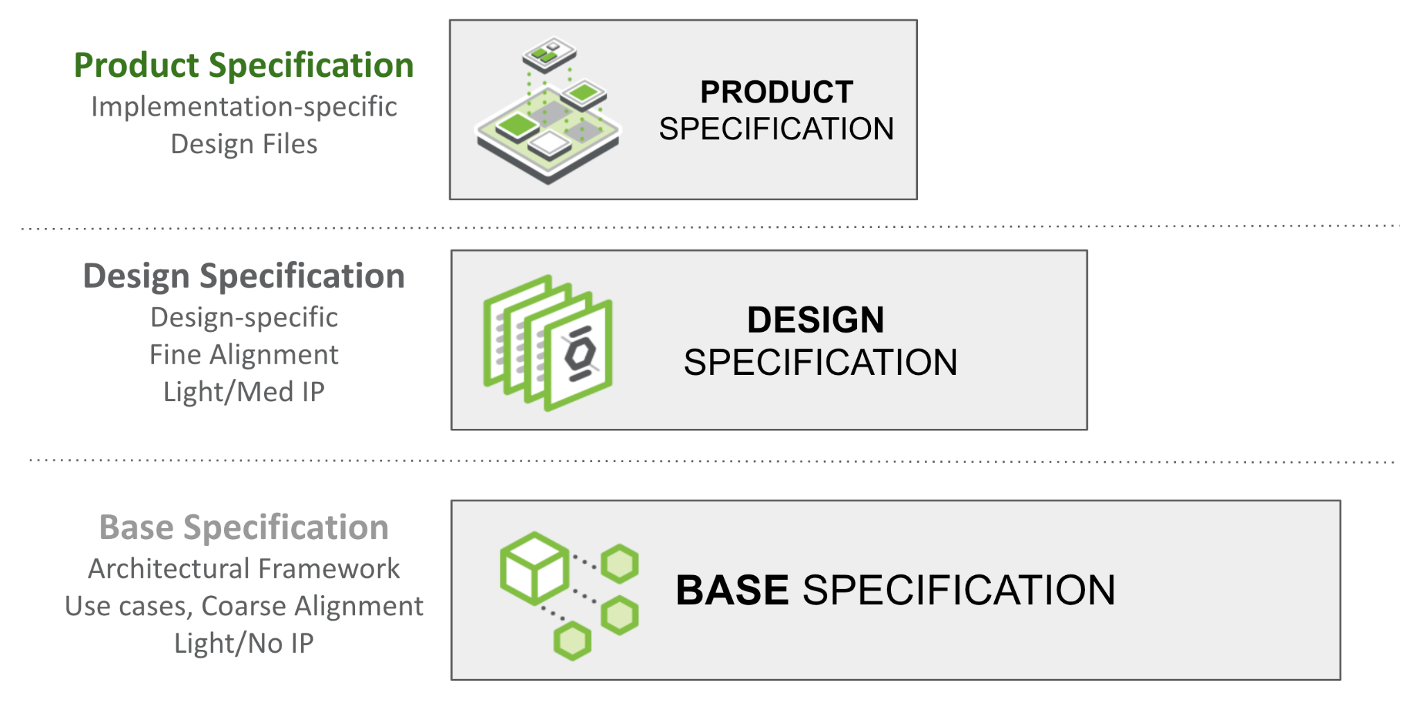

Figure 1: Specification Layers

## Usage

The sections displayed within this document contain examples. Any contributions that do not have any section may delete it. For example if the contribution is for a ORv3 labeling system- not many of the example sections herein apply, therefore contributors may delete.

## Base Specification Layer

The Base Specification is an architectural framework for coarse alignment— a requirements description for flexible hardware and software modules/layers to interoperate. Market requirements drive Base Specifications. Without defining details of a specific design, the Base Specification may be light on IP content. This structure enables and simplifies the process for multiple parties (including potential competitors) to engage in this phase.

Please see the [presentation](https://146a55aca6f00848c565-a7635525d40ac1c70300198708936b4e.ssl.cf1.rackcdn.com/images/4d14a1280e13c7dcf17123678eedc7e56053de96.pdf) and [recording](https://www.youtube.com/watch?v=IKqGFyE0V9E) on the Modular Contribution Process from the OCP Global Summit 2022 for more information.

This document defines the technical details for one of the following types of specifications:

* Base Specification for a de-facto standard (new standard with no hardware product)
* Base Specification for an intended physical <hardware product type>
* modification of an existing specification (state which existing spec is being modified)
  + either a complete revision update or
  + a minor version update

Note: Any supplier seeking OCP recognition for a hardware product must be 100% compliant with these Base requirements and subsequent design and product specifications as described.

## Design Specification Layer

The Design Specification captures customer requirements for finer alignment by building on the Base Specification (Spec). If a Base Specification provides general requirements and design goals, the Design Specifications has detail that further defines what specific role this contribution plays, and enough detailed design information such as high level board layouts etc that enables end users to begin the journey to realize this in the market. One or more parties may join to develop detailed design specs. Compared to the Base Specification, this effort typically contains significantly more detail such as future roadmaps and IP-related information. This group may have a multi-party NDA on their own (outside of the OCP umbrella) for the normal practice of developing products.

Design Specifications can be reused! I.e., if one contributor uses an indoor design specification, another team could reuse and make an outdoor specification. Having the same Base Specification for several Design Specifications will help increase the commonality of physical and logical interfaces to meet a set of common infrastructure hw/sw/fw requirements while allowing gen-to-gen variations or product differentiation.

This document defines the technical details for one of the following types of specifications:

* Design Specification for an intended physical <hardware product type>
* modification of an existing specification (state which existing spec is being modified)
  + either a complete version update or
  + a minor revision update
* a specification with additional detail over the Base Specification for a <product type> with a target of a product (for example, a reference design) typically being available in 180 days of approval of this Spec. Note, this timeline might be extendable, depending on the approval from OCP Project Leadership for the project from within this specification is being developed, in cases, for example, feedback/updates required from the Base Specification from which this is derived.

* Note: Few Base Specifications were submitted prior to the final approved template.

## Product Specification Layer

The Product Specification captures manufacturing requirements including all design and build files, building on the Design Specification. Typically even fewer companies will engage to create a single product specification, but the goal is to increase the total number of products that meet a Design Specification (derived from a Base Specification). The resulting Product Specification shall be contributed to OCP (via a Final Specification Agreement: FSA). A product typically goes through much effort for qualification and mass-production readiness beyond what specified in a typical design spec.

Product Specifications can be reused! I.e., assuming the base and design specifications allow, if one contributor creates a 110VAC design specification, another team could reuse and make an -48VDC product specification.

At Product(ization) Phase, even fewer companies may be involved to develop a specific final product for contribution to OCP. A Product may be submitted to OCP for “OCP Accepted™” or “OCP Inspired™” designation (with different levels of collateral such as a Design Package).

Please see the [presentation](https://146a55aca6f00848c565-a7635525d40ac1c70300198708936b4e.ssl.cf1.rackcdn.com/images/4d14a1280e13c7dcf17123678eedc7e56053de96.pdf) and [recording](https://www.youtube.com/watch?v=IKqGFyE0V9E) on the Modular Contribution Process from the OCP Global Summit 2022 for more information.

This document defines the technical details for one of the following types of specifications:

* Product Specification for an intended physical <hardware product type>
* modification of an existing product specification (state which existing spec is being modified)
  + either a complete version update or
  + a minor revision update
* a detailed specification for a <product type> with a product typically being available in 120 days of approval of this Spec.

Note: Any supplier seeking OCP recognition, for example OCP Accepted, for a hardware product, must be using a product spec that is 100% compliant with the preceding Base requirements, Design specification and these Product Specifications as described.

| DELETE THIS BLOCK BEFORE SUBMITTING |
| --- |
| INSTRUCTIONS FOR THE FOLLOWING SECTIONS:   * The following (Sections 5-8 are required to document features and functions of the contributed system, subsystem, platform, card, component or other unit as appropriate- and are broken out into layers. * The layout of the sections has some boilerplate and random examples. These are illustrative only. Please rearrange, add, delete, and change as necessary to describe the contribution. * Be sure to complete only the incremental requirements for each subsequent layer. (ex: Assume Base Specification and include only changes in the Product Specifications, etc…) * Please use the OCP Terminology Guidelines for Inclusion and Openness. * No NDA (Non-disclosure Agreement) or confidential material is to be included in this document, including charts and included materials. This will be an OPEN document. |

# 

# Overview

Describe your contribution and the modularity of this spec within the framework of modular specification process (this might be the openness tenet too) Include the problems it addresses. Explain its utility within the Open Compute Project ecosystem.

# 

# Base Specifications

# Repository Location (Strongly Recommended)

*It is highly recommended that OCP projects participate in a collaborative development process. OCP has GitHub resources available, with access control if/as needed, for this development process. Please request a repository for your contribution from your project leads.*

*Please identify OCP GitHub repository information.*

# Environmental Regulatory Compliance and Requirements

*Please describe any environmental regulations or requirements for any platform boards and full system, if applicable..*

*Note to author of this specification: This section can include the following but is not limited to the below items:*

* *UL/CE/NRTL/FCC/IEC/EN/etc Requirements*
* *RoHS/WEE directives, REACH regulations*
* *NEBS compliance requirements*
* *Operating temperature range*
* *Storage temperature range*
* *Transportation temperature range*
* *Shock and Vibration requirements*
* *Operating Altitude*

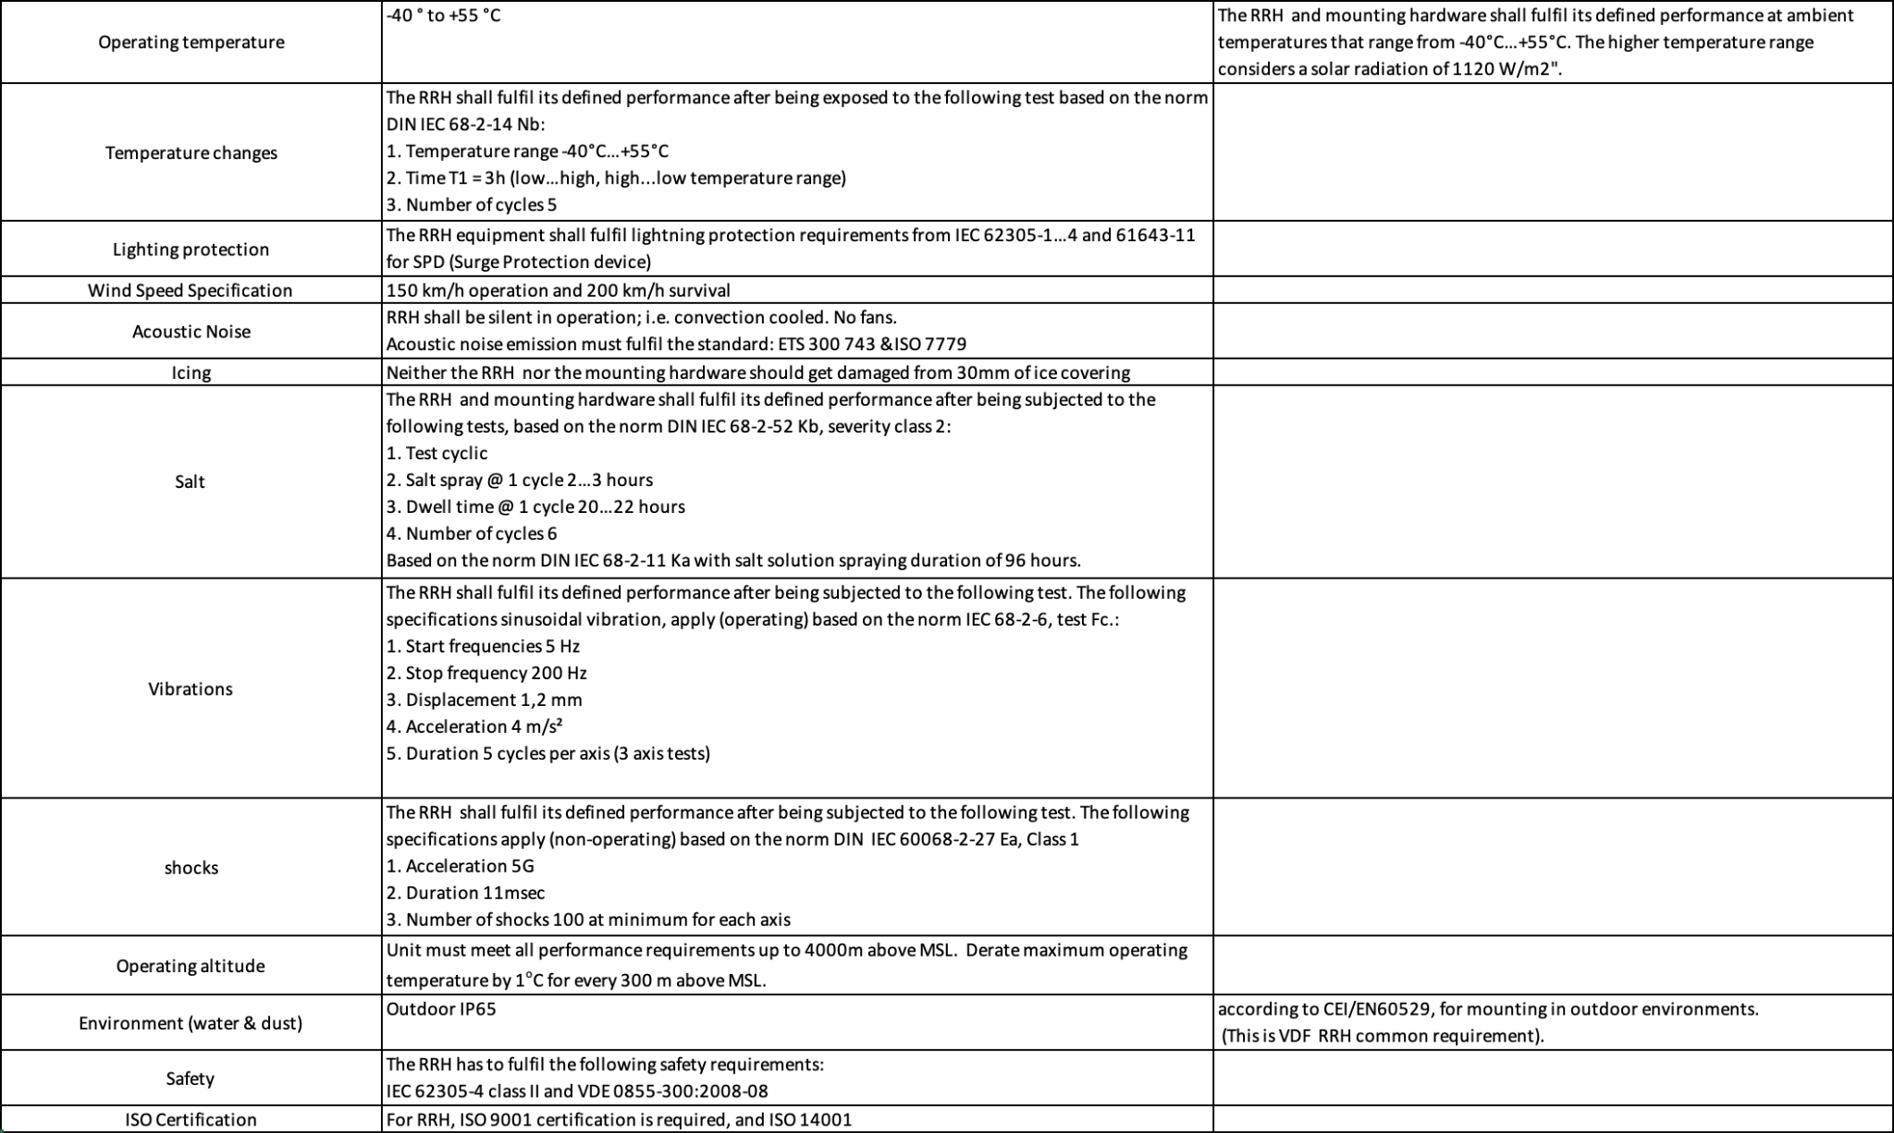

Example Outdoor Equipment Environmental Requirements

# Physical Specifications

# 

*Please describe the physical requirements for your contribution. This may be the limitations of the physical envelope.*

*If this specification defines a chassis type system, be sure to include the description of the chassis and associated modules, midplane, backplanes etc….*

*Note to author of this specification: This section can include the following but is not limited to the below items:*

* *Block Diagrams*
* *Form Factor Requirements*
* *Figures & Illustrations*

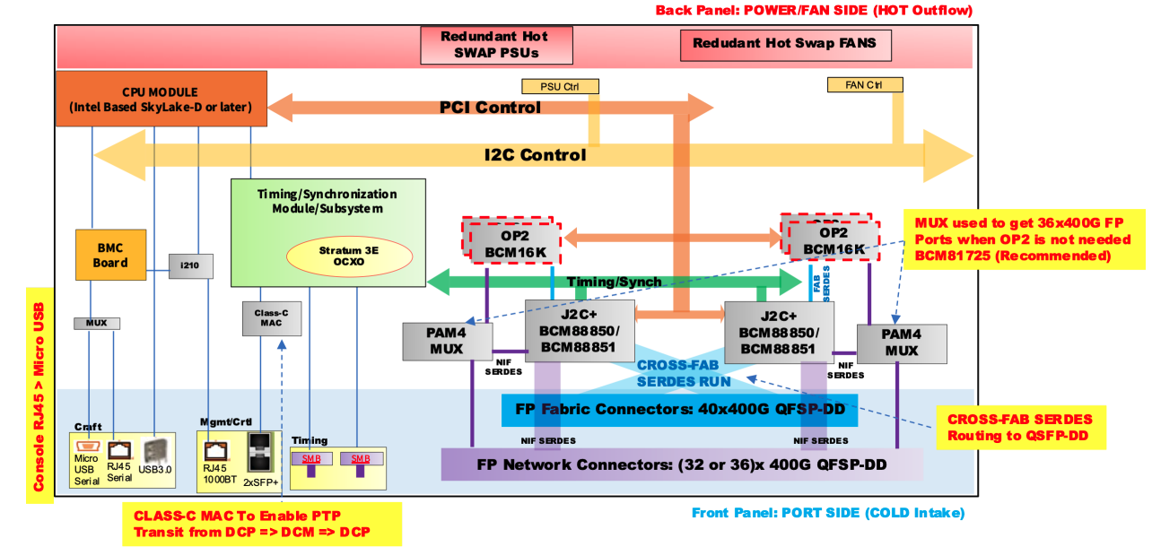

Sample Block Diagram

# Mechanical

*Please describe any key mechanical requirements of your contribution.*

## Rack Compatibility

*Please describe if your contribution will be used in a rack installation. If the contribution is rack mountable, the specification must be compliant with one of the following OCP approved rack types: OpenRack (V3.X and beyond), EIA-310, OpenEdge.*

## General Requirements

*Note to author of this specification: This section can include the following but is not limited to the below items:*

* *Chassis*
* *Single sled/double sled*

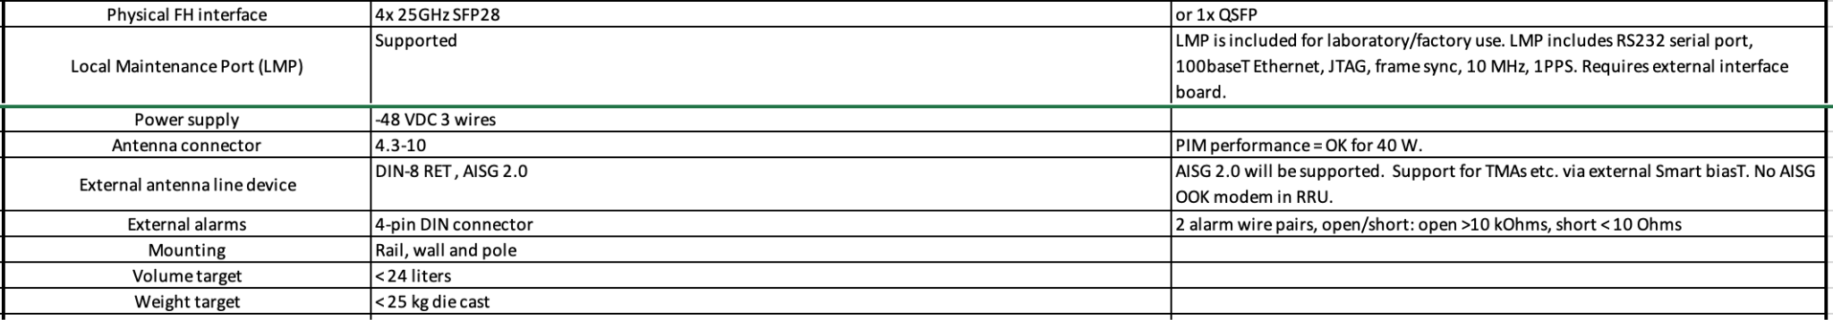

Dual-Band RRU Mechanical Requirements

# Electrical Requirements

*Please describe general electrical power requirements. Example: Power Input envelope +48VDC, 110VAC, peak/average power, etc…*

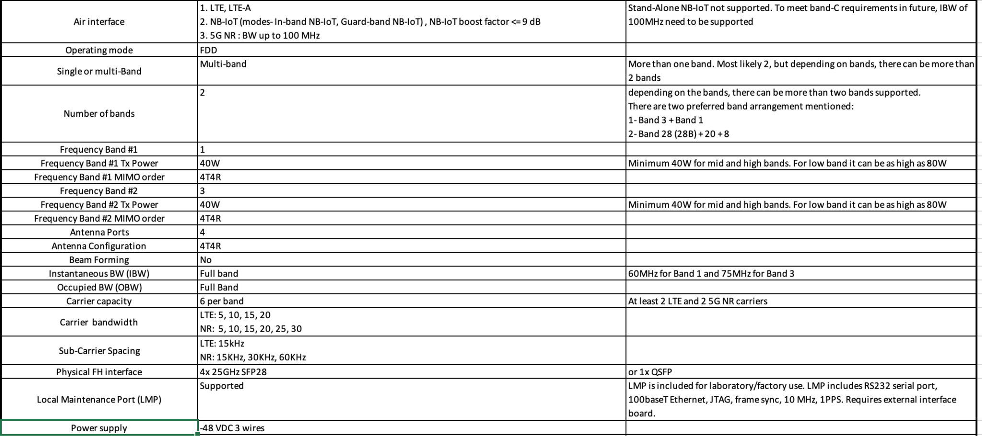

Dual-Band RRU Electrical Requirements

# Thermal Design Requirements

*Please describe the thermal design requirements for your contribution and any CFD and/or thermal models etc...*

*Note to author of this specification: Examples include:*

* *Cooling Media*
* *Flow Management*
* *Fan Controls*

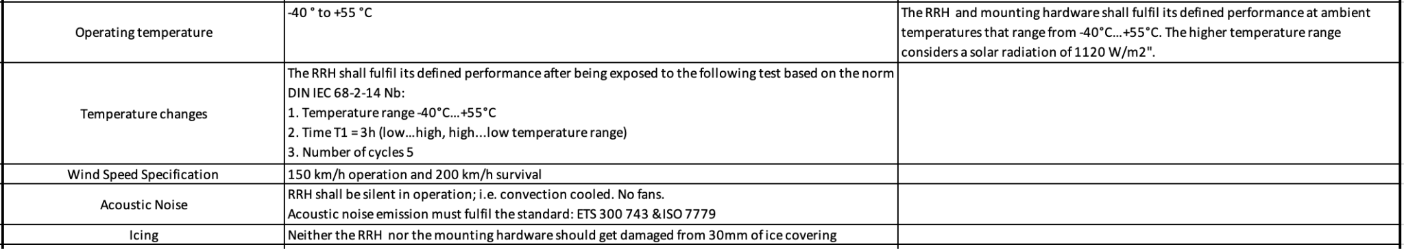

Example: Dual-Band RRU Thermal Requirements

# Interfaces

*Please describe the I/O System of the contribution, be sure to delineate the control and data planes. Block diagrams here.*

**

Sample Block Diagram Showing Interfaces

## Signal List

*Note to author of this specification: Examples only*

* *Power and Ground*
* *Synchronization/Clocks*
* *PCIe*
* *i2C/i3C*
* *GPIO*
* *USB 3.0*

## Rear Side Power, I/O, Expansion Board and Midplane Subsystems

*Please describe any modular design implementation requirements of the contribution.*

*Note to author of this specification: This section can include the following but is not limited to the below items:*

* *​​Overview of Footprint and Population Options*
* *Rear Side Connectivity*
* *Midplane*
* *Expansion*
* *Fixed, redundant, modular, pluggable, adapter?*
* *Power, Grounding etc…*

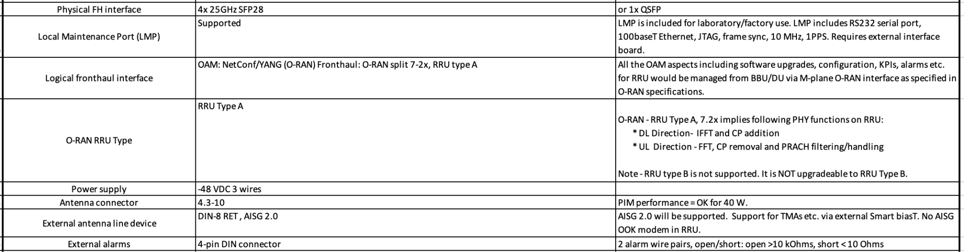

Example: Dual-Band RRU External Interface Requirements

# Onboard Power System

*Please describe the architecture of the power systems and requirements in your contribution.*

*Note to author of this specification: This section can include the following but is not limited to the below items:*

* *Voltage Regulation*
* *Power Management*
* *Input voltages*
* *Hot swap controller circuit*
* *Hard drive power*
* *Power Tree*
* *Power Policy*
* *Power Budget*
* *Platform Budget*
* *Capacitive Load*

**

Example: Dual-Band RRU Power Supply Requirements

# Prescribed Materials

*Please list any prescribed materials in your contribution. Specific components that are being referenced but not contributed.*

*Note to author of this specification: This section can include the following but is not limited to the below items:*

* *Disallowed components*

*Any specifically required components with no substitution (Ex: IC Intel JHL8540 or greater for Thunderbolt 4 compliance)*

# System Firmware

*Please document firmware function, and necessary features, licensing and distribution rights, explanation of ownership rights, system build utilities, test regime explanations, standards compliance, options for changing firmware configurations, and how firmware upgrades can be accomplished.*

*Note to author of this specification: This section can include the following but is not limited to the below items:*

* *BIOS Chip*
* *BIOS Feature Requirements*

# Hardware Management

*Please document the hardware management implementation of your contribution. Include Firmware (BIOS) optional Board Management Controller (BMC), Data Center Secure Control Modules (DC-SCM), etc.*

*Note to author of this specification: This section* ***should*** *include the following below items:*

* *Statement on whether the contribution supports out-of-band manageability.*
* *Statement on the modularity of the manageability architecture. (i.e. is an OCP management module used?)*

*Note to author of this specification: This section* ***can*** *include the following but is not limited to the below items:*

* *Architecture of out-of-band management*
  + *Dedicated or shared NIC*
  + *In which power state is the OOB management enabled*
* *A list of on-platform manageability interfaces:*
  + *Connections: I2C/I3C, SMBus, RMII,*
  + *Transport Protocol: MCTP, IPMI (KCS, BT, etc)*
  + *Commands constructs: PLDM …, IPMI, SPDM, CPER*
* *A list of components whose firmware which can updated programmatically*
  + *Which support failover/rollback mechanisms*
* *A list of diagnostic or management LEDs supported*
* *A list of minimum telemetry/sensors*
* *A list of minimum controls*
* *Whether conformance to OCP Profiles has been tested*
* *For Arm-based Servers, whether conformance to Arm Server Base Manageability Requirements Specification has been followed. If so, please also indicate the conformance level (e.g., M2)*

# Compliance

*This* ***mandatory*** *section is also applicable to create the checklist for the consumers of the specification to adhere to in order for them to declare it complies to the requirements. This applies to any implementations (OCP Marketplace or not) that declare compliance with this specification.*

*(Example Compliance Table Follows)*

| ***ITEM*** | ***REQUIREMENT*** | ***REFERENCE*** | ***MANDATORY*** |
| --- | --- | --- | --- |
| *1* | *If scalable HPM depth >372.5mm (from origin), additional Zone 2 KOZs shall be*  *implemented.* | *10.3.2 (multiple items)* | *Y* |
| *2* | *Optional: The device shall only clear the Timestamp Origin field to 000b in the Timestamp (Feature*  *Identifier 0Eh) on a main power cycle or NVM Subsystem Reset (e.g., NSSR). The device*  *shall not clear the Timestamp Origin field on a power cycle of only AUX power.* | *NVMe-OPT-4* | *N* |
| *3* | *Any supplier seeking OCP recognition for a hardware product based on this specification*  *shall be 100% compliant* | *4* | *Y* |

*All Products seeking OCP Accepted™ Product Recognition shall have source code and binary*

*blobs submitted for BMC, if applicable.*

*The BMC management source code shall be uploaded at:*

[*https://github.com/opencomputeproject/Hardware-Management/[vendor_name]/[product_name*](https://github.com/opencomputeproject/Hardware-Management/%5Bvendor_name%5D/%5Bproduct_name)*]*

# Security

*Please briefly describe security functionality that* ***your specification requires and recommends\*****.*

*Include a “required by” date on recommendations. Omit what doesn’t apply and add whatever*

*is missing. Remember, the greater the detail in this specification, the less flexibility is allowed during design and product specification.*

*Note to author of this specification: This section* ***can*** *include the following but is not limited to the below items:*

* *For cryptography, key derivation, key agreement, and hashing, identify*

*o Required algorithms, modes, strengths, and usage*

*o Required compliance with national or international standards*

*o Acceptable sources of entropy*

*o Acceptable certifications of algorithm implementations*

*o Recommended certifications of cryptographic modules*

*o Recommended safeguards against cryptanalysis by quantum computers*

* *Required flow of Secure Boot starting from hardware root(s) of trust*
* *Required measurements from hardware reset through firmware*
* *Required attestation protocols*
* *Acceptable environments and processes for provisioning keys and device secrets*
* *Acceptable processes for identifying CVEs and distributing field updates to address them*
* *Acceptable Secure Boot and Attestation key lifecycle management (from generation through*
* *revocation)*
* *Recommended standards for software bills of materials*
* *Recommended firmware recovery mechanisms*

*\*Required = Required now*

*Acceptable = Required now and chosen from a list of acceptable alternatives*

*Recommended = Recommended now, but required by a specified future date*

*Please find guidance and examples in the OCP Security Project documents on* [*Secure Boot*](https://www.opencompute.org/documents/secure-boot-2-pdf)*,* [*Attestation of System Components*](https://www.opencompute.org/documents/attestation-v1-0-20201104-pdf)*,* [*Common Security Threats*](https://www.opencompute.org/documents/common-security-threats-notes-1-pdf)*, and the* [*CSIS document on Secure Firmware Development Best Practices*](https://www.opencompute.org/documents/csis-firmware-security-best-practices-position-paper-version-1-0-pdf)*.*

All products seeking OCP Inspired™ or OCP Accepted™ Product Recognition shall have a

completed Security Profile in the latest Supplier Requirements Checklist. Whether the answer is

a yes or no, the profile must be completed. For the base specification, a statement about the intention for the contribution to comply with OCP Inspired™ or OCP Accepted™ Product Recognition requirements.

# Software Support (*Strongly* recommended)

*Please identify any software required including notional architecture and features required to support the contribution. Identify OCP GitHub repository information.*

# Arm SystemReady (only for Arm-based Systems) Requirement

Please document if this contribution is designed to meet requirements for the Arm SystemReady certificate.

*Note to author of this specification: This section* ***can*** *include the following but is not limited to the below items:*

* For Server Sleds, Open Edge Sleds and Monolithic Servers, the certification of either SystemReady SR or LS certification is required.
* For Storage and Networking, the certification of SystemReady SR, LS, ES, or IR is recommended.
* For Systems that are SystemReady SR, ES or IR certified, SystemReady Security Interface Extension (SIE) certification is recommended.

More details on Arm SystemReady can be found at https://www.arm.com/architecture/system-architectures/systemready-certification-program.

# References (recommended)

[1] “Title”, publication year, publication journal/conference/standard, volume, pages, link to publication if available.

# Design Specifications

Reminder to authors, this section refines the previous section, so it’s unnecessary to strictly repeat the previous sections, only add what modifies and refines the previous. This section is for the Design Specifications. If a Base Specification provides general requirements and design goals, the Design Specifications has detail that further defines what specific role this contribution plays, and enough detailed design information such as high level board layouts, enumerations, etc that enables end users to utilize this part of the specifications to begin the journey to realize this design.

## Repository Information

*It is highly recommended that OCP projects participate in a collaborative development process. OCP has GitHub resources available, with access control if/as needed, for this development process. This is increasingly important at the Design Specification stage to enable future collaboration on potential improvements and revisions.*

*Please identify OCP GitHub repository information for the Design Specifications.*

# Environmental Regulatory Compliance and Requirements

*Please describe any environmental regulations or requirements for any platform boards and full system, if applicable..*

*Note to author of this specification: This section can include the following but is not limited to the below items:*

* *UL/CE/NRTL/FCC/IEC/EN/etc Requirements*
* *RoHS/WEE directives, REACH regulations*
* *NEBS compliance requirements*
* *Operating temperature range*
* *Storage temperature range*
* *Transportation temperature range*
* *Shock and Vibration requirements*
* *Operating Altitude*

**

Example Outdoor Equipment Environmental Requirements

# Physical Specifications

*Please describe the physical requirements for your contribution. This may be the limitations of the physical envelope.*

*If this specification defines a chassis type system, be sure to include the description of the chassis and associated modules, midplane, backplanes etc….*

*Note to author of this specification: This section can include the following but is not limited to the below items:*

* *Block Diagrams*
* *Form Factor Requirements*
* *Figures & Illustrations*

**

Sample Block Diagram

# Mechanical

*Please describe any key mechanical requirements of your contribution.*

## Rack Compatibility

*Please describe if your contribution will be used in a rack installation. If the contribution is rack mountable, the specification must be compliant with one of the following OCP approved rack types: OpenRack (V3.X and beyond), EIA-310, OpenEdge.*

## General Requirements

*Note to author of this specification: This section can include the following but is not limited to the below items:*

* *Chassis*
* *Single sled/double sled*

**

Example: Dual-Band RRU Mechanical Requirements

# Electrical Requirements

*Please describe general electrical power requirements. Example: Power Input envelope +48VDC, 110VAC, peak/average power, etc…*

**

Example: Dual-Band RRU Electrical Requirements

# Thermal Design Requirements

*Please describe the thermal design requirements for your contribution and any CFD and/or thermal models etc...*

*Note to author of this specification: Examples include:*

* *Cooling Media*
* *Flow Management*
* *Fan Controls*

**

Example: Dual-Band RRU Thermal Requirements

# Interfaces

*Please describe the I/O System of the contribution, be sure to delineate the control and data planes. Block diagrams here.*

**

Sample Block Diagram Showing Interfaces

## Signal List

*Note to author of this specification: Examples only*

* *Power and Ground*
* *Synchronization/Clocks*
* *PCIe*
* *i2C/i3C*
* *GPIO*
* *USB 3.0*

## Rear Side Power, I/O, Expansion Board and Midplane Subsystems

*Please describe any modular design implementation requirements of the contribution.*

*Note to author of this specification: This section can include the following but is not limited to the below items:*

* *​​Overview of Footprint and Population Options*
* *Rear Side Connectivity*
* *Midplane*
* *Expansion*
* *Fixed, redundant, modular, pluggable, adapter?*
* *Power, Grounding etc…*

**

Example: Dual-Band RRU External Interface Requirements

# Onboard Power System

*Please describe the architecture of the power systems and requirements in your contribution.*

*Note to author of this specification: This section can include the following but is not limited to the below items:*

* *Voltage Regulation*
* *Power Management*
* *Input voltages*
* *Hot swap controller circuit*
* *Hard drive power*
* *Power Tree*
* *Power Policy*
* *Power Budget*
* *Platform Budget*
* *Capacitive Load*

**

Example: Dual-Band RRU Power Supply Requirements

# Prescribed Materials

*Please list any prescribed materials in your contribution. Specific components that are being referenced but not contributed.*

*Note to author of this specification: This section can include the following but is not limited to the below items:*

* *Disallowed components*
* *Any specifically required components with no substitution (Ex: IC Intel JHL8540 or greater for Thunderbolt 4 compliance)*

# System Firmware

*Please document firmware function, and necessary features, licensing and distribution rights, explanation of ownership rights, system build utilities, test regime explanations, standards compliance, options for changing firmware configurations, and how firmware upgrades can be accomplished.*

*Note to author of this specification: This section can include the following but is not limited to the below items:*

* *BIOS Chip*
* *BIOS Feature Requirements*

# Hardware Management

*Please document the hardware management implementation of your contribution. Include Firmware (BIOS) optional Board Management Controller (BMC), Data Center Secure Control Modules (DC-SCM), etc.*

*Note to author of this specification: This section* ***should*** *include the following below items:*

* *Statement on whether the contribution supports out-of-band manageability.*
* *Statement on the modularity of the manageability architecture. (i.e. is an OCP management module used?)*

*Note to author of this specification: This section* ***can*** *include the following but is not limited to the below items:*

* *Architecture of out-of-band management*
  + *Dedicated or shared NIC*
  + *In which power state is the OOB management enabled*
* *A list of on-platform manageability interfaces:*
  + *Connections: I2C/I3C, SMBus, RMII,*
  + *Transport Protocol: MCTP, IPMI (KCS, BT, etc)*
  + *Commands constructs: PLDM …, IPMI, SPDM, CPER*
* *A list of components whose firmware which can updated programmatically*
  + *Which support failover/rollback mechanisms*
* *A list of diagnostic or management LEDs supported*
* *A list of minimum telemetry/sensors*
* *A list of minimum controls*
* *Whether conformance to OCP Profiles has been tested*
* *For Arm-based Servers, whether conformance to Arm Server Base Manageability Requirements Specification has been followed. If so, please also indicate the conformance level (e.g., M2)*

# Compliance

*This* ***mandatory*** *section is also applicable to create the checklist for the consumers of the specification to adhere to in order for them to declare it complies to the requirements. This applies to any implementations (OCP Marketplace or not) that declare compliance with this specification.*

*(Example Compliance Table Follows)*

| ***ITEM*** | ***REQUIREMENT*** | ***REFERENCE*** | ***MANDATORY*** |
| --- | --- | --- | --- |
| *1* | *If scalable HPM depth >372.5mm (from origin), additional Zone 2 KOZs shall be*  *implemented.* | *10.3.2 (multiple items)* | *Y* |
| *2* | *Optional: The device shall only clear the Timestamp Origin field to 000b in the Timestamp (Feature*  *Identifier 0Eh) on a main power cycle or NVM Subsystem Reset (e.g., NSSR). The device*  *shall not clear the Timestamp Origin field on a power cycle of only AUX power.* | *NVMe-OPT-4* | *N* |
| *3* | *Any supplier seeking OCP recognition for a hardware product based on this specification*  *shall be 100% compliant* | *4* | *Y* |

# Security

*Please briefly describe security functionality that* ***your specification requires and recommends\*****.*

*Include a “required by” date on recommendations. Omit what doesn’t apply and add whatever*

*is missing. Remember, the greater the detail in this specification, the less flexibility is allowed during design and product specification.*

*Note to author of this specification: This section* ***can*** *include the following but is not limited to the below items:*

* *For cryptography, key derivation, key agreement, and hashing, identify*

*o Required algorithms, modes, strengths, and usage*

*o Required compliance with national or international standards*

*o Acceptable sources of entropy*

*o Acceptable certifications of algorithm implementations*

*o Recommended certifications of cryptographic modules*

*o Recommended safeguards against cryptanalysis by quantum computers*

* *Required flow of Secure Boot starting from hardware root(s) of trust*
* *Required measurements from hardware reset through firmware*
* *Required attestation protocols*
* *Acceptable environments and processes for provisioning keys and device secrets*
* *Acceptable processes for identifying CVEs and distributing field updates to address them*
* *Acceptable Secure Boot and Attestation key lifecycle management (from generation through*
* *revocation)*
* *Recommended standards for software bills of materials*
* *Recommended firmware recovery mechanisms*

*\*Required = Required now*

*Acceptable = Required now and chosen from a list of acceptable alternatives*

*Recommended = Recommended now, but required by a specified future date*

*Please find guidance and examples in the OCP Security Project documents on* [*Secure Boot*](https://www.opencompute.org/documents/secure-boot-2-pdf)*,* [*Attestation of System Components*](https://www.opencompute.org/documents/attestation-v1-0-20201104-pdf)*,* [*Common Security Threats*](https://www.opencompute.org/documents/common-security-threats-notes-1-pdf)*, and the* [*CSIS document on Secure Firmware Development Best Practices*](https://www.opencompute.org/documents/csis-firmware-security-best-practices-position-paper-version-1-0-pdf)*.*

All products seeking OCP Inspired™ or OCP Accepted™ Product Recognition shall have a

completed Security Profile in the latest Supplier Requirements Checklist. Whether the answer is

a yes or no, the profile must be completed. For the base specification, a statement about the intention for the contribution to comply with OCP Inspired™ or OCP Accepted™ Product Recognition requirements.

# Software Support (*Strongly* recommended)

*Please identify any software required and/or tools used to validate the hardware design and include test and validation using virtual simulation, design decisions based upon digital models, or proof of manufacturability via 3-D tools.*

# Arm SystemReady (only for Arm-based Systems) Requirement

Please document if this contribution is designed to meet requirements for the Arm SystemReady certificate.

*Note to author of this specification: This section* ***can*** *include the following but is not limited to the below items:*

* For Server Sleds, Open Edge Sleds and Monolithic Servers, the certification of either SystemReady SR or LS certification is required.
* For Storage and Networking, the certification of SystemReady SR, LS, ES, or IR is recommended.
* For Systems that are SystemReady SR, ES or IR certified, SystemReady Security Interface Extension (SIE) certification is recommended.

More details on Arm SystemReady can be found at https://www.arm.com/architecture/system-architectures/systemready-certification-program.

# References (recommended)

[1] “Title”, publication year, publication journal/conference/standard, volume, pages, link to publication if available.

# Product Specifications

Reminder to authors, this section refines the previous sections, so it’s unnecessary to strictly repeat the previous sections, only add what modifies the previous. This section, the Product Specifications, requires further detail such as but not limited to bills of materials with component part numbers, supporting gerber/design, software, tools and any other files required to be able to produce the contribution.

## Repository Information

*It is highly recommended that OCP projects participate in a collaborative development process. OCP has GitHub resources available, with access control if/as needed, for this development process. This is essential at the Product Specification stage to keep important design information readily accessible and to enable future collaboration on potential improvements and revisions.*

# *Please identify OCP GitHub repository information for the Product Specifications.*

# Environmental Regulatory Compliance and Requirements

*Please describe any environmental regulations or requirements for any platform boards and full system, if applicable..*

*Note to author of this specification: This section can include the following but is not limited to the below items:*

* *UL/CE/NRTL/FCC/IEC/EN/etc Requirements*
* *RoHS/WEE directives, REACH regulations*
* *NEBS compliance requirements*
* *Operating temperature range*
* *Storage temperature range*
* *Transportation temperature range*
* *Shock and Vibration requirements*
* *Operating Altitude*

**

Example Outdoor Equipment Environmental Requirements

# Physical Specifications

*Please describe the physical requirements for your contribution. This may be the limitations of the physical envelope.*

*If this specification defines a chassis type system, be sure to include the description of the chassis and associated modules, midplane, backplanes etc….*

*Note to author of this specification: This section can include the following but is not limited to the below items:*

* *Block Diagrams*
* *Form Factor Requirements*
* *Figures & Illustrations*

**

Sample Block Diagram

# Mechanical

*Please describe any key mechanical requirements of your contribution.*

## Rack Compatibility

*Please describe if your contribution will be used in a rack installation. If the contribution is rack mountable, the specification must be compliant with one of the following OCP approved rack types: OpenRack (V3.X and beyond), EIA-310, OpenEdge.*

## General Requirements

*Note to author of this specification: This section can include the following but is not limited to the below items:*

* *Chassis*
* *Single sled/double sled*

**

Example Dual-Band RRU Mechanical Requirements

# Electrical Requirements

*Please describe general electrical power requirements. Example: Power Input envelope +48VDC, 110VAC, peak/average power, etc…*

**

Example Dual-Band RRU Electrical Requirements

# Thermal Design Requirements

*Please describe the thermal design requirements for your contribution and any CFD and/or thermal models etc...*

*Note to author of this specification: Examples include:*

* *Cooling Media*
* *Flow Management*
* *Fan Controls*

**

Example Dual-Band RRU Thermal Requirements

# Interfaces

*Please describe the I/O System of the contribution, be sure to delineate the control and data planes. Block diagrams here.*

**

Sample Block Diagram Showing Interfaces

## Signal List

*Note to author of this specification: Examples only*

* *Power and Ground*
* *Synchronization/Clocks*
* *PCIe*
* *i2C/i3C*
* *GPIO*
* *USB 3.0*

## Rear Side Power, I/O, Expansion Board and Midplane Subsystems

*Please describe any modular design implementation requirements of the contribution.*

*Note to author of this specification: This section can include the following but is not limited to the below items:*

* *​​Overview of Footprint and Population Options*
* *Rear Side Connectivity*
* *Midplane*
* *Expansion*
* *Fixed, redundant, modular, pluggable, adapter?*
* *Power, Grounding etc…*

**

Example Dual-Band RRU External Interface Requirements

# Onboard Power System

*Please describe the architecture of the power systems and requirements in your contribution.*

*Note to author of this specification: This section can include the following but is not limited to the below items:*

* *Voltage Regulation*
* *Power Management*
* *Input voltages*
* *Hot swap controller circuit*
* *Hard drive power*
* *Power Tree*
* *Power Policy*
* *Power Budget*
* *Platform Budget*
* *Capacitive Load*

**

Example Dual-Band RRU Power Supply Requirements

# Prescribed Materials

*Please list any prescribed materials in your contribution. Specific components that are being referenced but not contributed.*

*Note to author of this specification: This section can include the following but is not limited to the below items:*

* *Disallowed components*

*Any specifically required components with no substitution (Ex: IC Intel JHL8540 or greater for Thunderbolt 4 compliance)*

# System Firmware

*Please document firmware function, and necessary features, licensing and distribution rights, explanation of ownership rights, system build utilities, test regime explanations, standards compliance, options for changing firmware configurations, and how firmware upgrades can be accomplished.*

*Note to author of this specification: This section can include the following but is not limited to the below items:*

* *BIOS Chip*
* *BIOS Feature Requirements*

# Hardware Management

*Please document the hardware management implementation of your contribution. Include Firmware (BIOS) optional Board Management Controller (BMC), Data Center Secure Control Modules (DC-SCM), etc.*

*Note to author of this specification: This section* ***should*** *include the following below items:*

* *Statement on whether the contribution supports out-of-band manageability.*
* *Statement on the modularity of the manageability architecture. (i.e. is an OCP management module used?)*

*Note to author of this specification: This section* ***can*** *include the following but is not limited to the below items:*

* *Architecture of out-of-band management*
  + *Dedicated or shared NIC*
  + *In which power state is the OOB management enabled*
* *A list of on-platform manageability interfaces:*
  + *Connections: I2C/I3C, SMBus, RMII,*
  + *Transport Protocol: MCTP, IPMI (KCS, BT, etc)*
  + *Commands constructs: PLDM …, IPMI, SPDM, CPER*
* *A list of components whose firmware which can updated programmatically*
  + *Which support failover/rollback mechanisms*
* *A list of diagnostic or management LEDs supported*
* *A list of minimum telemetry/sensors*
* *A list of minimum controls*
* *Whether conformance to OCP Profiles has been tested*
* *For Arm-based Servers, whether conformance to Arm Server Base Manageability Requirements Specification has been followed. If so, please also indicate the conformance level (e.g., M2)*

# Compliance

*This* ***mandatory*** *section is also applicable to create the checklist for the consumers of the specification to adhere to in order for them to declare it complies to the requirements. This applies to any implementations (OCP Marketplace or not) that declare compliance with this specification.*

*For a product specification, this declaration should refer to the base/design specifications, can include blanket statements if complies, and absolutely needs to list exceptions.*

*(Example Compliance Table Follows)*

| ***ITEM*** | ***REQUIREMENT*** | ***REFERENCE*** | ***COMPLIES*** |
| --- | --- | --- | --- |
| *1* | *If scalable HPM depth >372.5mm (from origin), additional Zone 2 KOZs shall be*  *implemented.* | *10.3.2 (multiple items)* | *Y* |
| *2* | *Optional: The device shall only clear the Timestamp Origin field to 000b in the Timestamp (Feature*  *Identifier 0Eh) on a main power cycle or NVM Subsystem Reset (e.g., NSSR). The device*  *shall not clear the Timestamp Origin field on a power cycle of only AUX power.* | *NVMe-OPT-4* | *N* |
| *3* | *Any supplier seeking OCP recognition for a hardware product based on this specification*  *shall be 100% compliant* | *4* | *Y* |

*All Products seeking OCP Accepted™ Product Recognition shall have source code and binary*

*blobs submitted for BMC, if applicable.*

*The BMC management source code shall be uploaded at:*

*https://github.com/opencomputeproject/Hardware-Management/[vendor_name]/[product_name]*

# Security

*Please briefly describe security functionality that* ***your specification requires and recommends\*****.*

*Include a “required by” date on recommendations. Omit what doesn’t apply and add whatever*

*is missing. Remember, the greater the detail in this specification, the less flexibility is allowed during design and product specification.*

*Note to author of this specification: This section* ***can*** *include the following but is not limited to the below items:*

* *For cryptography, key derivation, key agreement, and hashing, identify*

*o Required algorithms, modes, strengths, and usage*

*o Required compliance with national or international standards*

*o Acceptable sources of entropy*

*o Acceptable certifications of algorithm implementations*

*o Recommended certifications of cryptographic modules*

*o Recommended safeguards against cryptanalysis by quantum computers*

* *Required flow of Secure Boot starting from hardware root(s) of trust*
* *Required measurements from hardware reset through firmware*
* *Required attestation protocols*
* *Acceptable environments and processes for provisioning keys and device secrets*
* *Acceptable processes for identifying CVEs and distributing field updates to address them*
* *Acceptable Secure Boot and Attestation key lifecycle management (from generation through*
* *revocation)*
* *Recommended standards for software bills of materials*
* *Recommended firmware recovery mechanisms*

*\*Required = Required now*

*Acceptable = Required now and chosen from a list of acceptable alternatives*

*Recommended = Recommended now, but required by a specified future date*

*Please find guidance and examples in the OCP Security Project documents on* [*Secure Boot*](https://www.opencompute.org/documents/secure-boot-2-pdf)*,* [*Attestation of System Components*](https://www.opencompute.org/documents/attestation-v1-0-20201104-pdf)*,* [*Common Security Threats*](https://www.opencompute.org/documents/common-security-threats-notes-1-pdf)*, and the* [*CSIS document on Secure Firmware Development Best Practices*](https://www.opencompute.org/documents/csis-firmware-security-best-practices-position-paper-version-1-0-pdf)*.*

All products seeking OCP Inspired™ or OCP Accepted™ Product Recognition shall have a

completed Security Profile in the latest Supplier Requirements Checklist. Whether the answer is

a yes or no, the profile must be completed. For the base specification, a statement about the intention for the contribution to comply with OCP Inspired™ or OCP Accepted™ Product Recognition requirements.

# Software Support (*Strongly* recommended)

*Please identify any software required and/or tools used to validate the hardware design and include test and validation using virtual simulation, design decisions based upon digital models, or proof of manufacturability via 3-D tools.*

# Arm SystemReady (only for Arm-based Systems) Requirement

Please document if this contribution is designed to meet requirements for the Arm SystemReady certificate.

*Note to author of this specification: This section* ***can*** *include the following but is not limited to the below items:*

* For Server Sleds, Open Edge Sleds and Monolithic Servers, the certification of either SystemReady SR or LS certification is required.
* For Storage and Networking, the certification of SystemReady SR, LS, ES, or IR is recommended.
* For Systems that are SystemReady SR, ES or IR certified, SystemReady Security Interface Extension (SIE) certification is recommended.

More details on Arm SystemReady can be found at https://www.arm.com/architecture/system-architectures/systemready-certification-program.

# References (recommended)

[1] “Title”, publication year, publication journal/conference/standard, volume, pages, link to publication if available.

# Appendix A - Checklist for Steering Committee (SC) approval of this Specification (to be completed by contributor(s) of this Spec)

Complete all the checklist items in the table with links to the section where it is described in this spec or an external document .

| **Item** | **Status or Details** | **Link to detailed explanation** |
| --- | --- | --- |
| Is this contribution entered into the OCP Contribution Portal? | Yes or No | If no, please state the reason. |
| Was it approved in the OCP Contribution Portal? | Yes or No | If no, please state the reason. |
| Is there a Supplier(s) that is building a product based on this Spec? (Supplier must be an OCP Solution Provider) | Yes or No | List Supplier Name(s) |
| Will Supplier(s) have the product available for GENERAL AVAILABILITY within 120 days? | Yes or No | If more time is required, please state the timeline and reason for extension request.  Please have each Supplier fill out Appendix B. |

# 

# Appendix B-__ <supplier name> - OCP Supplier Information and Hardware Product Recognition Checklist

(to be provided by each supplier seeking OCP recognition for a Hardware Product based on this specification)

Company:

Contact Info:

Product Name:

Product SKU#:

Link to Product Landing Page:

The following is needed for OCP hardware product recognition:

**For OCP Inspired™**

* All Suppliers must be an OCP Member. All corporate membership levels are eligible.
* Declare product is 100% compliant with specification
* Complete the [OCP Inspired™ Product Recognition Checklist](https://docs.google.com/spreadsheets/d/1p7g_bPWzgXDDTkxbOEOkLrbvfKmqVWspKOi7J20yJcE/copy?resourcekey=0-UWRTqqnBa3i6BcSNTDJfmA#gid=963873675), which includes hardware management conformance checks and security profile.

**For OCP Accepted™**

* All Suppliers must be an OCP Member. All corporate membership levels are eligible.
* Complete the [OCP Accepted™ Product Recognition Checklist](https://docs.google.com/spreadsheets/d/1SNqQYCta4CVsZsZcRRVR5A779YyCHxA2gLSINlFtnTs/copy#gid=963873675), which includes hardware management conformance checks, security profile and open system firmware conformance checks.
* Submit a design package meeting [OCP Hardware Design Guideline Contribution Checklist](https://docs.google.com/document/u/0/d/1SdLlXxn_jz__t8I33ATraYvHDYX3go3w_rR4LJ1PNTE/edit) (if not already submitted by the contributor). If already submitted, declare the product is 100% compliant with the design package.
* Submit a firmware package including a firmware image, build scripts, documentation, test results and a tool that verifies modifications
* Submit the BMC source code, if applicable to product type

Please complete the OCP Inspired™ Product Recognition Submission Checklist or OCP Accepted™ Product Recognition Checklist and the following table.

| **Item** | **Details** | **Links** |
| --- | --- | --- |
| Which product recognition? | OCP Accepted™ or OCP Inspired™ | Provide link for the appropriate Product Checklist |
| If OCP Accepted™, who provided the Design Package? |  | Link to OCP Contribution Database |
| Where can a potential adopter purchase the product? |  | Link to OCP Marketplace |

# 

# Appendix C - Contribution Process FAQs

As a contributor to a hardware specification, here are some questions that often come up.

1. What are acceptable types of hardware specification am I able to contribute to OCP? Is it any of the below?
   1. base, design or product specification for a de-facto standard (new standard with no hardware product on the horizon)
   2. base, design or product specification for an intended physical <hardware product type> (product may be coming but within the next 12-15 months for base and design specification, with a product specification with design files resulting in a product in 3-6 months)
   3. modification of an existing specification (state which existing spec is being modified)
      1. either a complete revision update or
      2. a minor version update
      3. Note: errata does not require a specification update. Only an errata statement.
   4. an architectural specification for <product types> that may incorporate several/multiple specifications, types, standards and other components into a logical system for given purposes.
      1. this may include a/any specification(s) that strictly conforms to an architectural specification
      2. this may include a/any specification(s) that is/are standalone or conforms to an architectural specification
   5. A Base, Design and Product Specification in a single document.
   6. *If none of the above, please contact OCP Staff for consultation.*
2. How do I know if what I am contributing will be accepted by OCP?
   1. Before contributing any specifications, please contact either OCP Staff (Michael Schill, Rob Coyle or Bijan Nowroozi) or the Project Lead for the Project that best represents your contribution. For example, if you are contributing a Server Specification, please contact one of the Server Project Leads. You can see all the Projects [here](https://www.opencompute.org/projects).
   2. The OCP Foundation, Project Leadership and OCP Community are resources to help you navigate the process.
3. What is the contribution process for my hardware spec?
   1. Follow the flow for your spec type [here](https://docs.google.com/presentation/d/1PlXGLhCdgVEGWQ0hLYdAQEH5qCScwYij/edit#slide=id.g10e20dc1292_0_101).
   2. This flow is subject to change so please check with the OCP Staff for more information or any questions.
4. What if my spec is not developed yet and I want to collaborate with other companies?
   1. Please contact either OCP Staff (Michael Schill, Rob Coyle or Bijan Nowroozi) or the Project Lead for the Project that best represents your contribution.
   2. They will help you find other collaborators and help you with the contribution process for a multi-party contribution.
5. I have a question on the Contribution License Agreement.
   1. Please contact OCP Staff and we can help you with questions.
6. Do I need to have a product in order to contribute a spec?
   1. Please see Q1. Some types of specs do not require an immediate product. Some do. Please work with the OCP Staff on better direction on your specification type.
7. How do I know if someone else is already working on this idea?
   1. Please discuss with the Project Leadership and/or the OCP Foundation staff.
8. What other considerations are there?
   1. The OCP Foundation encourages contributors to consult with the Project Leadership and/or the OCP Foundation staff as early as possible in the development cycle. There may be others in the community who are willing and able to help share some of the development effort.
   2. It may be desirable for speed to gather key collaborators and work together outside of public meetings, with a closed CLA. Just be aware of the tradeoffs such as potential collaboration is missed and the idea may not be as strong as it could be with additional eyes on it. Some recommendations are:
      1. even if the idea is worked on in a closed CLA group, find ways to hold regular public briefings
      2. consider opening the CLA group as soon as possible and
      3. be open to the possibility of duplication of effort by others whom were not aware and chance this approach will end up fracturing of the potential total market by having subsequent exclusive groups working in parallel